**New College Lanarkshire**

**User Manual**

**Simple Library**

**DANAYAL IFTIKHAR**

# Installation Requirements

**System Requirements**: 1.6GHz or higher processor; 1GB RAM; 10GB available hard disk space; Direct X9 capable video card with a 1024x768 or higher resolution display; Windows 7 or higher.

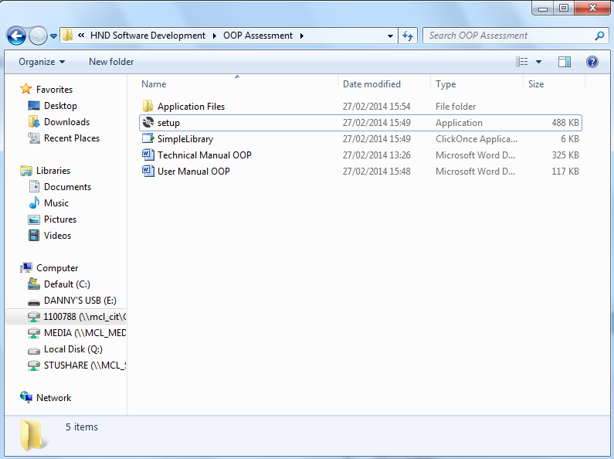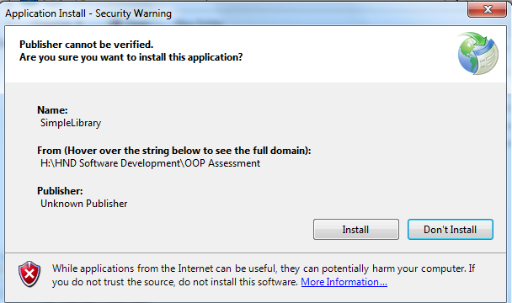**Installation**: To install, simply go to the folder with the file called “Setup” and double click it. Following this a security warning will appear asking to verify the publisher and whether or not to install the file – click “Install” and run the file.

# User Guide

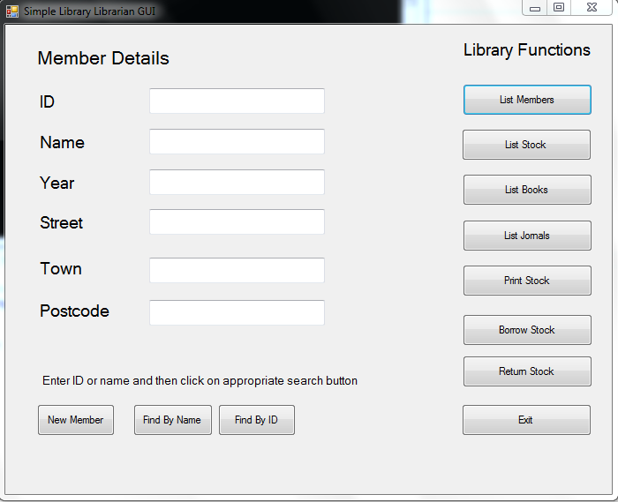

17

1

2

16

15

3

14

4

13

5

12

6

11

10

7

9

8

|  |  |  |  |
| --- | --- | --- | --- |
| **1** | ID | Textbox to display member ID |  |
| **2** | Name | Textbox to display Name |  |
| **3** | Year | Textbox to display year of birth |  |
| **4** | Street | Textbox to display street |  |
| **5** | Town | Textbox to display town |  |
| **6** | Postcode | Textbox to display postcode |  |

|  |  |  |  |  |
| --- | --- | --- | --- | --- |
| **Button Number** | **Button Name** | **Button Purpose** | **Errors (if any)** | **Solution** |
| **7** | New Member | Click to create new member | See Figure 11 | |
| **8** | Find By Name | Click to find member using name | See Figure 1 | |
| **9** | Find by ID | Click to find member using ID | See Figure 2 | |
| **10** | Exit | Click to exit application | See Figure 3 | |
| **11** | Return Stock | Click to return borrowed item to stock | See Figure 4 | |
| **12** | Borrow Stock | Click to borrow item to a valid member | See Figure 5 | |
| **13** | Print Stock | Click to display stock list in .txt file | See Figure 6 | |
| **14** | List Journals | Click to list all journals in the library | See Figure 7 | |
| **15** | List Books | Click to list all books available in library | See Figure 8 | |
| **16** | List Stock | Click to list all types of stock available | See Figure 9 | |
| **17** | List Members | Click to list all members in a console window | See Figure 10 | |

Figure 1

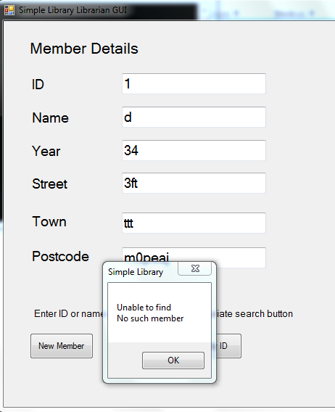

If you cannot find a member it may be because one hasn’t been created. Click Create Member on the Simple Library window to create a member.



Figure 2

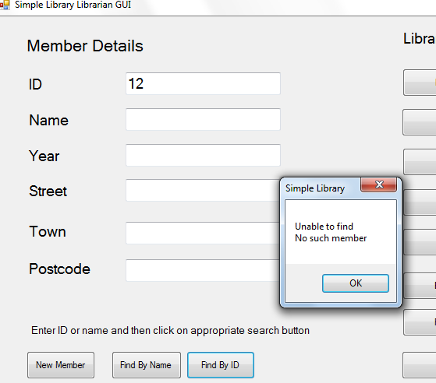

As with the “Find by Name” function, if a member ID which doesn’t exist is searched it will show the error in the diagram to the left. To fix this create a New Member using the corresponding button and after an ID is allocated you may search using that ID.

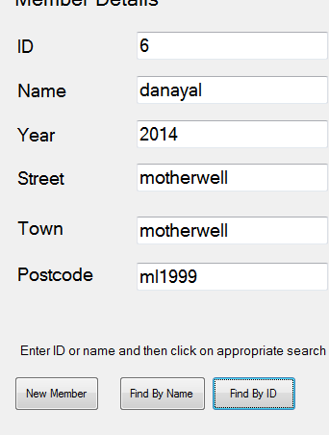

Figure 3

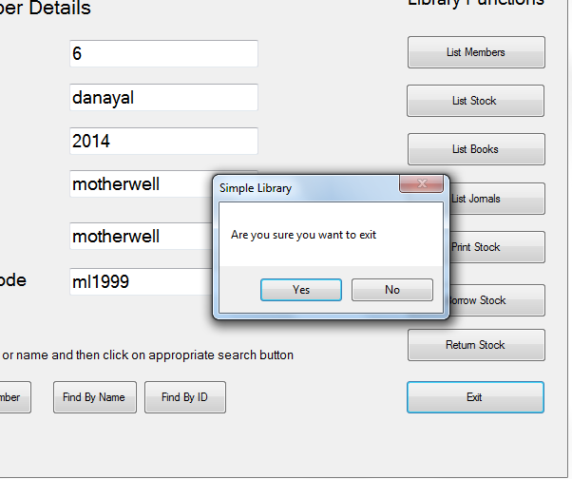

Simply click on the “Exit” button and on the dialog click “Yes”. Alternatively click “No” to return to the application.

Figure 4

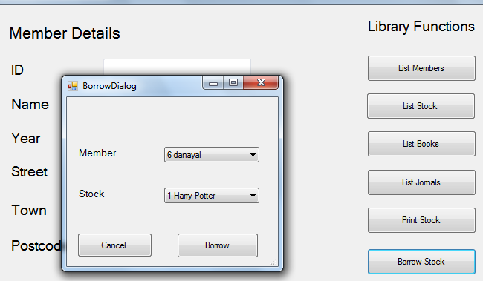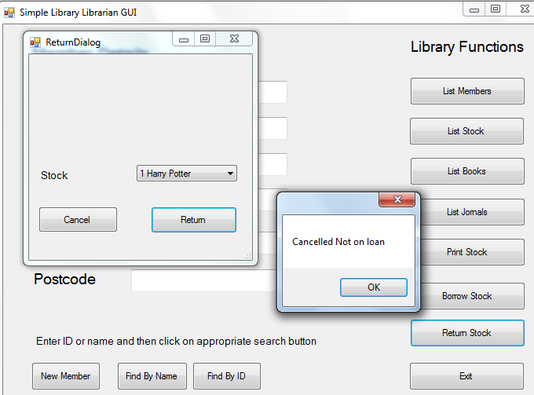

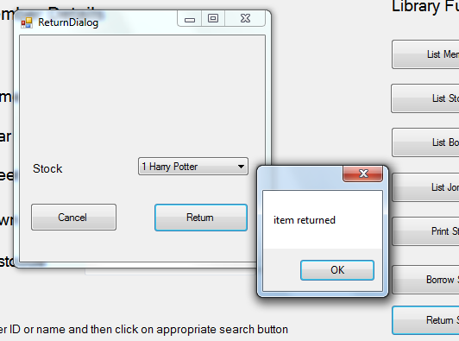

When clicking “Return Stock” a dialog will appear with a drop down box from which you may select which book to return. Select a book and click “Return”. If the error message above appears “Cancelled not on loan” then the book hasn’t been borrowed. To fix this click “Borrow Stock” and select a book to borrow; after this go back to Return Stock and select the borrowed book to return successfully.

Figure 5

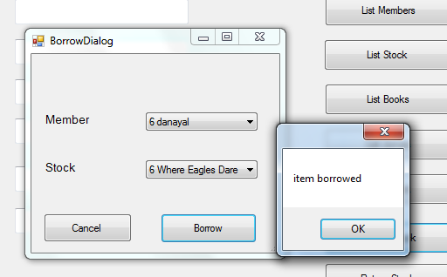

Click on the “Borrow Stock” button – after the dialog appears select from the available members and which book to borrow from the drop down boxes, and finally click “Borrow” to take it out the stock.

Figure 6

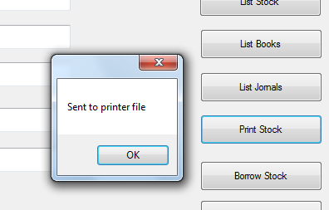

Click on “Print Stock” to send the list of stock to a .txt file in the debug folder of the program.

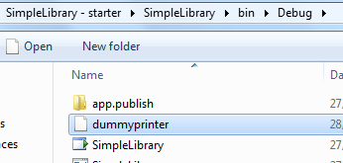

Figure 7



Click on “List Journals” to list all available journals with their corresponding volumes in the command prompt.

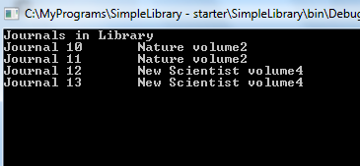

Figure 8



Click on “List Books” to list all available books in the library with their corresponding authors in the command prompt.

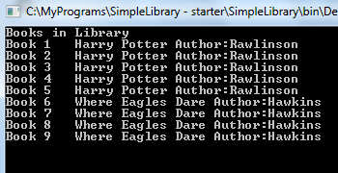

Figure 9



Click on “List Stock” to list all stock in the library.

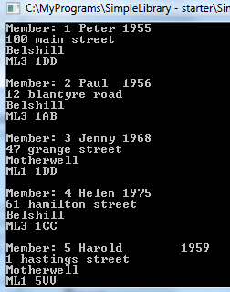

Figure 10

Click on “List Members” to list all existing and created members with their corresponding details in the command prompt.

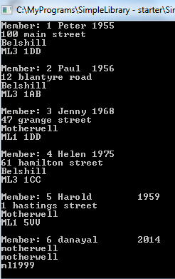

Click on “New Member” to create a member and then enter the details on the application page for that member and click “Update”. To view the created member click “List Members” and it will appear on the command prompt.

Figure 11



